**DAILY ONLINE ACTIVITIES SUMMARY**

|  |  |  |  |
| --- | --- | --- | --- |
| **Date:** | 26/05/2020 | **Name:** | Krishnitha |
| **Sem & Sec** | 4th sem, A Section | **USN:** | 4AL18CS039 |
| **Online Test Summary** | | | |
| **Subject** | Design and Analysis of Algorithm | | |
| **Max. Marks** | 30 | **Score** | 26 |
| **Certification Course Summary** | | | |
| **Course** | 1)STEPathon-communication skills [ICT ACEDAMY]  2)Introduction to IoT | | |
| **Certificate Provider** | 1) THE HINDU  2) CISCO Academy | **Duration:** | 1) 2hrs  2) 2hrs |
| **Coding Challenges** | | | |
| **Problem Statement:**   1. Write a java Program to remove all the Tens in the given array. 2. Given an array A of size N where the array elements contain values from 1 to N with duplicates, the task is to find total number of subarrays which start and end with the same element. 3. Write a program in C to print all permutations of a given string using pointers. | | | |
| **Status:** Executed | | | |
| **Uploaded the report in GitHub** | | YES | |
| **If yes Repository name** | | <https://github.com/krishnitha/Java-coding>  <https://github.com/krishnitha/C-coding> | |
| **Uploaded the report in slack** | | YES | |

Online Test Details:

Today we had assessment in the subject Design and Analysis of Algorithm. It was based on first module of this subject. There were total 30 number of questions of 1 mark each.

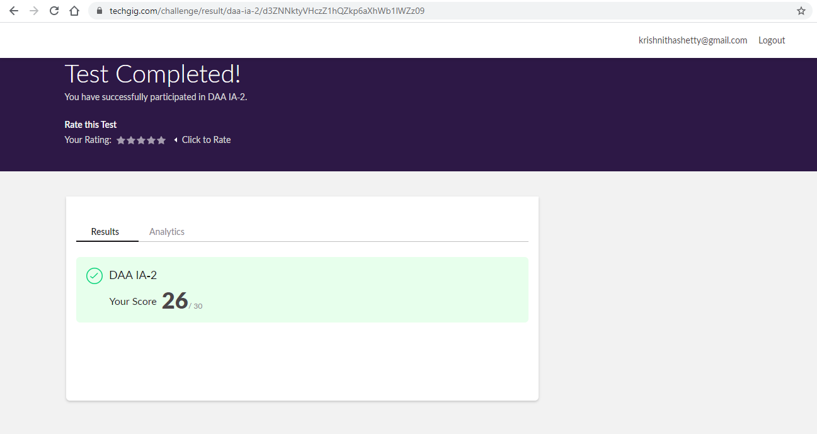

Certification Course Details:

I had done the certification course “THE STEPathon9” by The Hindu group on 25/05/2020, the course is based on communication skills. This course has a series of video-based webisodes or lessons which form an exciting story about a group of friends as they take a trip across India. Each webisode focuses on various language skills like reading, writing, listening, speaking, grammar, vocabulary. Today I have successfully completed this course.

Today I have started a new certification course on INTRODUCTION TO IoT By CISCO NETWORKING ACADEMY. This Introduction to Internet of Things 2.0 course is designed for people wishing to explore the Internet of Things and the impact it as on our everyday lives. It is not the intention of this course to teach about the IoT in depth but to provide a general understanding of the IoT and how it allows for digitization of daily tasks.

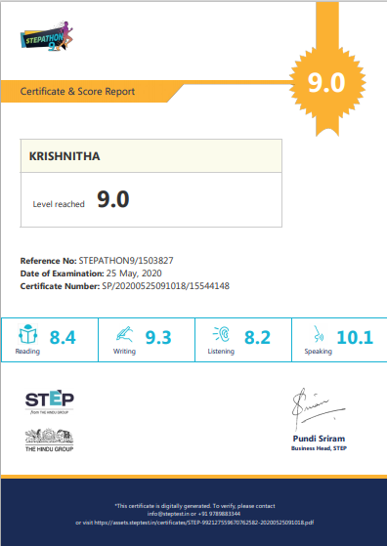

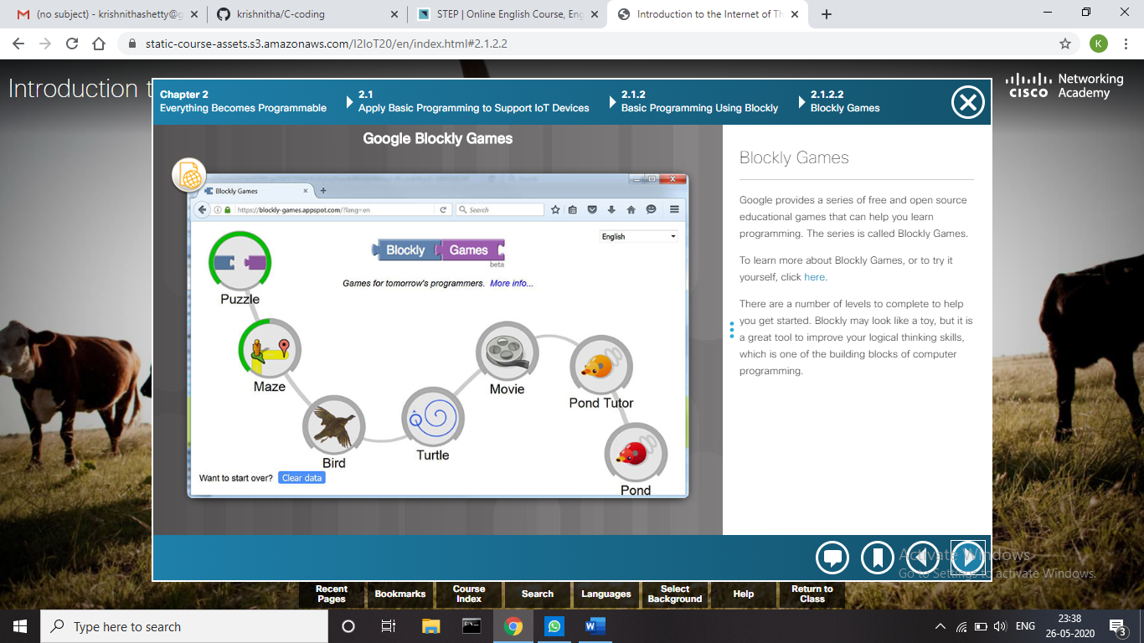

Coding Challenges Details:

Problem 1:  Write a JAVA Program to remove all the Tens in the given array.

**Explanation:** Return a version of the given array where all the 10's have been removed. The remaining elements should shift left towards the start of the array as needed, and the empty spaces at the end of the array should be 0. So {1, 10, 10, 2} yields {1, 2, 0, 0}. You may modify and return the given array or make a new array.

**Example:**  
withoutTen([1, 10, 10, 2]) → [1, 2, 0, 0]  
withoutTen([10, 2, 10]) → [2, 0, 0]

**Input:** First line should read number of array elements. Second Line should read the array elements which includes atleast two 10.

**Output:** Array which contains elements without 10.

**Solution:** Uploaded it in GitHub.

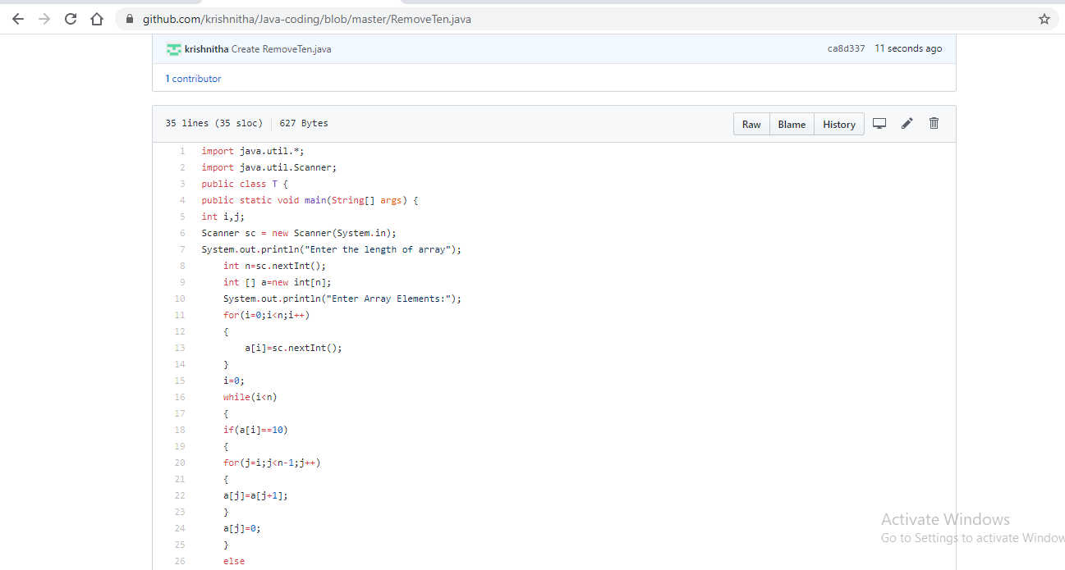

Problem 2: Given an array A of size N where the array elements contain values from 1 to N with duplicates, the task is to find total number of subarrays which start and end with the same element.

**Input:** A[ ] = {1, 2, 1, 5, 2}

**Output:** 7

**Explanation:**  
Total 7 sub-array of the given array are {1}, {2}, {1}, {5}, {2}, {1, 2, 1} and {2, 1, 5, 2} are start and end with same element.

**Solution:** Uploaded it in GitHub.

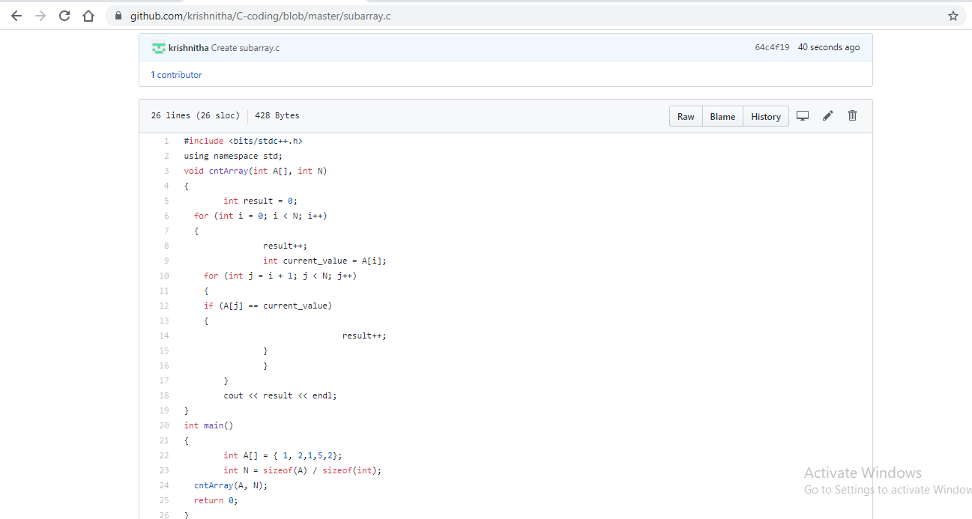

Problem 3: Write a program in C to print all permutations of a given string using pointers.

**Input:**Enter the Input String: abcd

**Expected Result:**The permutations of the string are :abcd abdc acbd acdb adcb adbc bacd badc bcad bcda bdca bdac cbad cbda cabd cadb cdab cdba dbca dbac dcba dcab dacb dabc

**Solution:** Uploaded it in GitHub.

